Randall Keith Benjamin
Associate Administrator for Highway Policy and External Affairs
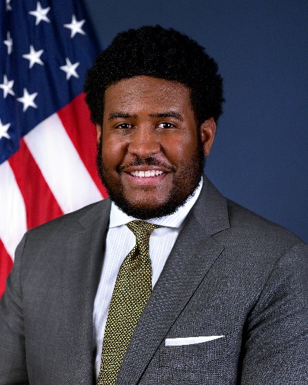
Randall (Keith) Benjamin II serves as Associate Administrator for Highway Policy and External Affairs for the Federal Highway Administration (FHWA) at the U.S. Department of Transportation (U.S. DOT). He serves to advance the mission and goals of FHWA while working with all transportation stakeholders, including Members of Congress, State agencies, local communities, and other mobility users. Mr. Benjamin leads the Office of Policy and Governmental Affairs which is responsible for a variety of critical and diverse topics ranging from managing congressional affairs; housing FHWA’s traffic and transportation performance data; collaborating with the international community on new highway technology, transportation research, and program innovations; and, performing studies and analyses of national transportation policy options. As a specialist with a multi-modal transportation background, Mr. Benjamin brings experience as a transportation professional in government, labor, and advocacy.
Prior to Mr. Benjamin’s swearing in on August 30, 2021, he served as the Director of the Department of Traffic and Transportation for the city of Charleston, South Carolina where he refocused the department on equitable mobility and passed the first citywide transportation plan in history. He also represented the city on the CARTA Transit Board, Charleston Aviation Authority, and the Berkeley-Charleston-Dorchester Council of Governments.
Previously, Mr. Benjamin formed the Federal Transportation Equity Caucus as a member of the policy office under U.S. DOT Secretary Anthony Foxx and was a manager with the Safe Routes to School National Partnership. He also held increasingly senior government affairs roles with the Transport Workers Union of America, AFL-CIO representing 150,000 members across the airline, railroad, and transit sectors after serving multiple members of Congress.
Mr. Benjamin is a graduate and Deans awardee of Swarthmore College and a former fellow of both the American Council of Young Political Leaders (ACYPL) to Kenya and Ethiopia and the National Association of City Transportation Officials Leadership program.
Mr. Benjamin is happy to return Washington, D.C. where he lives with his wife and son.

